

SSK AIRWAYS

REDEFINIG THE EMIRATES



SHEHRYAR MALLICK (CS-012)

MUHAMMAD SAAD SHAIKH (CS-020)

muhammad KHALID (CS-043)

# CONTENTS

1. ABSTRACT
2. METHODOLOGY
   1. *FOR PASSENGERS*
      1. SIGN UP
      2. SIGN IN
      3. CHECK FLIGHTS
      4. GENERAL QUERIES
      5. LOCATION TO HEAD OFFICE
      6. ROYAL RENTAL SERVICE
      7. BOOKING
   2. *FOR MANAGEMENT*
      1. EMPLOYEES
      2. SCHEDULES
      3. PLANES OF ORGANIZATION
3. OBJECT ORIENTED
   1. *CLASSES*
   2. MULTIPLE INHERITANCE
   3. AGGREGATION
   4. OVERLOADING
   5. OVERRIDING
   6. EXCEPTION HANDLING
   7. MODULES
4. CONCLUSION

# ABSTRACT

As the world is modernizing and civilization is conquering new peaks of advancement the need to travel from one place to another is still a challenge. People need an easy and fast means of travelling which is provided by airplanes but still many inconveniences occur by using this wonder may it be by booking or losing luggage or it might be any other haphazard. This is where SSK AIRWAYS comes into the picture.

SSK AIRWAYS is an airline platform which enables it’s passengers to book a flight, check schedules, timings and it even lets you book a taxi from the airport to your hotel, and much more. It eradicates all the problems faced by a passenger by providing such luxuries.

It is also an organization platform which enables the officials to view the existing planes, schedules and finally it maintains the record of its employees (to be discussed later on) so that they can keep a track of all the things so that the passenger would not face any inconvenience and that they can operate things smoothly.

In short SSK AIRWAYS is an easy way to book a flight for yourself and your loved ones at the same time it facilitates the management of such a vast airline.

# METHODOLOGY

In this section we are going to elaborate all the functionalities of the SSK AIRWAYS.

## FOR PASSENGERS:

* + 1. *SIGN UP:* This option enables a user to develop a login ID for him/herself so that they can easily enjoy all the features granted by SSK AIRWAYS.

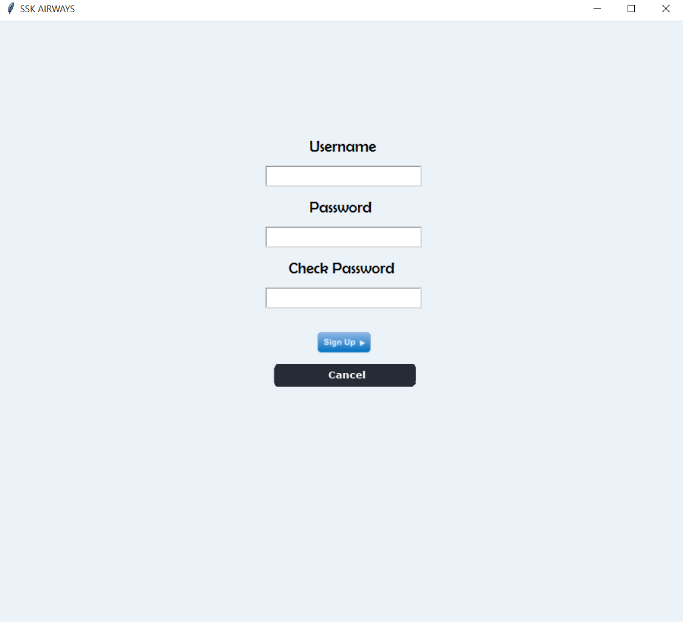

* + 1. *SIGN IN:* This option enables a passenger to login into an existing account and perform all the task he pleases to do.

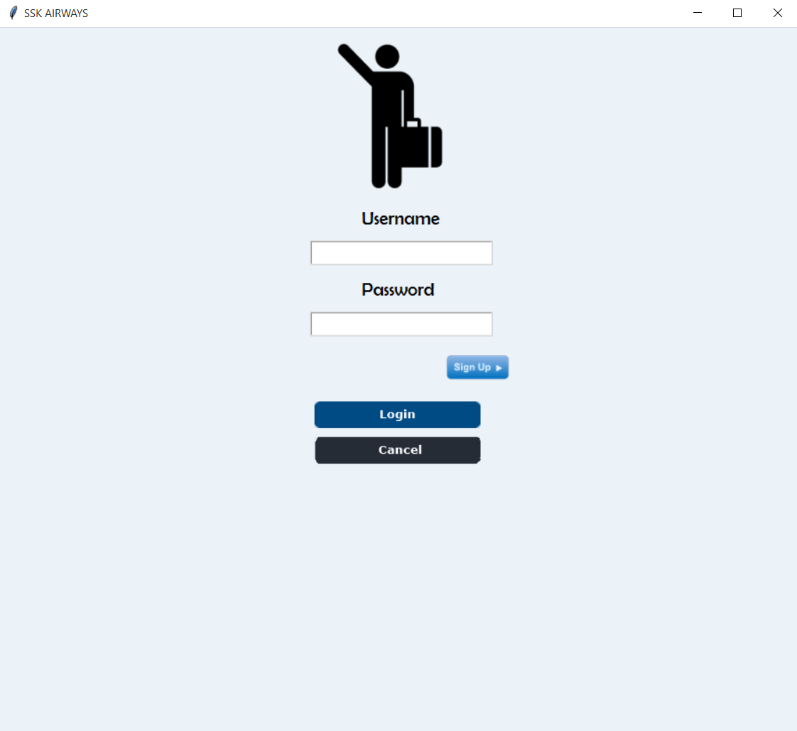

* + 1. *MAIN PAGE:* It contains all the features that are provided by SSK AIRWAYS.

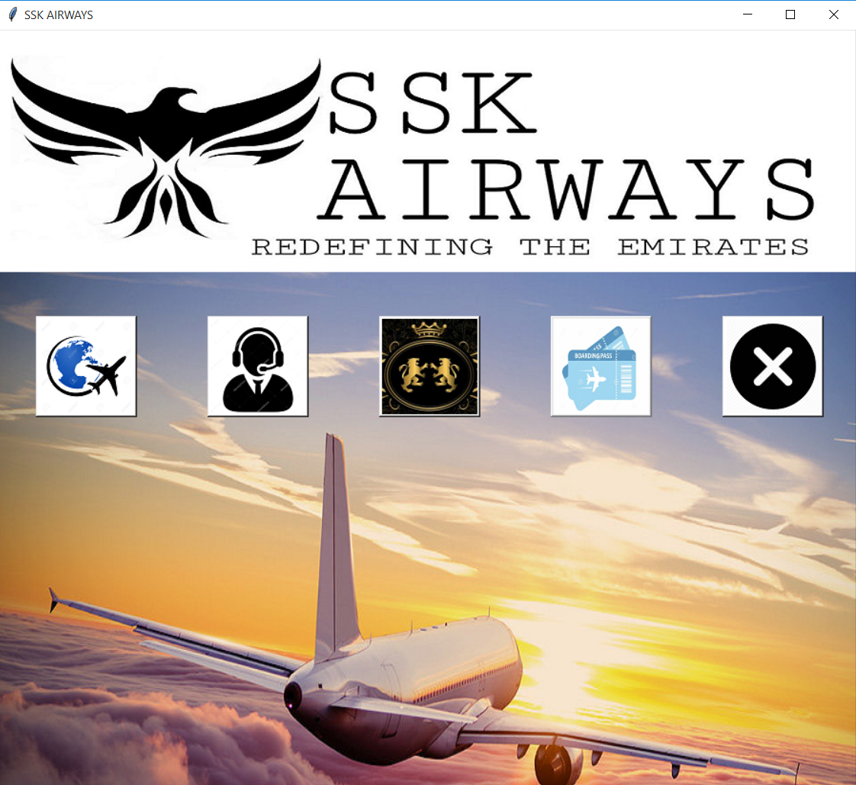

* + 1. *CHECK FLIGHTS:* This feature helps a user to view all the flights that are due to complete their journey thus helping them to decide which flight they want to book.

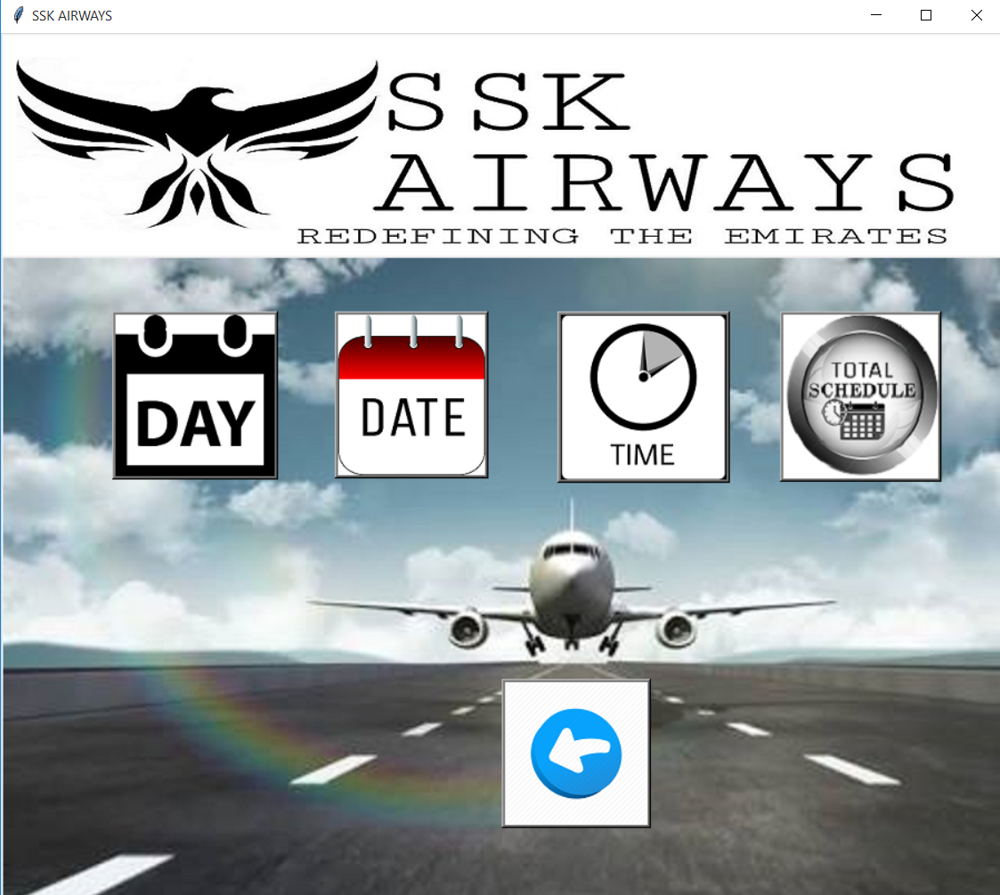

* + 1. *GENERAL QUERIES:* This feature comprises of all the question that might arise in a passengers mind already explained and answered.

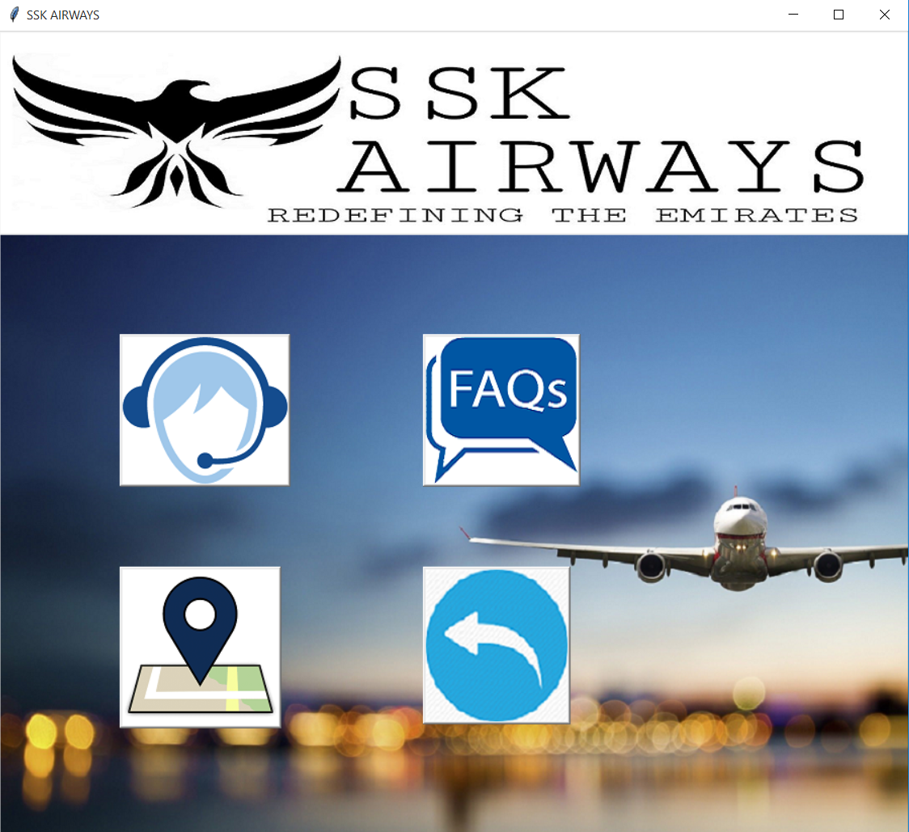

* + 1. *LOCATION TO HEAD OFFICE:* For a better experience or to satisfy our passengers personally we have provided a map with an easy route to our head office inorder to eliminate their problems.

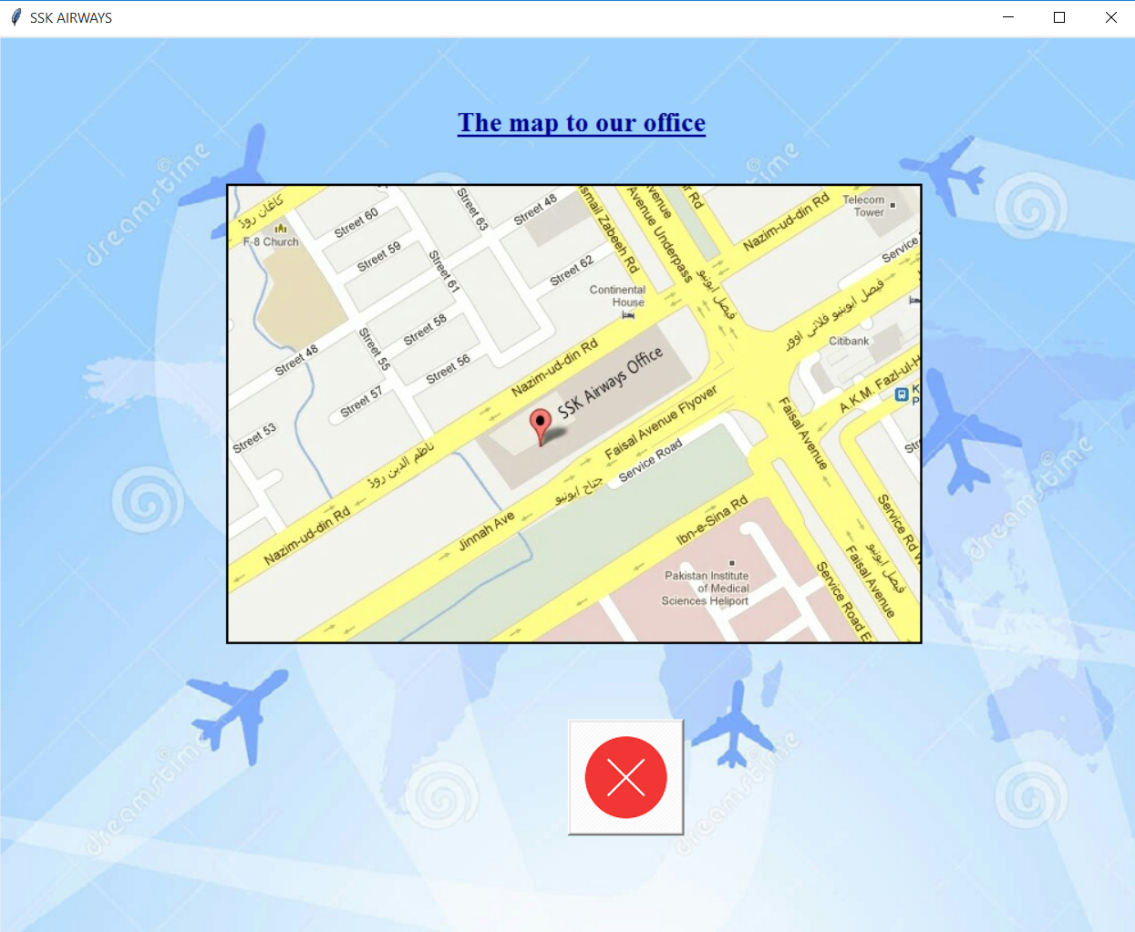

* + 1. *ROYAL RENTAL SERVICE:* This is an add-on feature and not a part of SSK AIRWAYS it is a taxi service which operates in a particular area helping our customers to reach their pre_booked hotels.

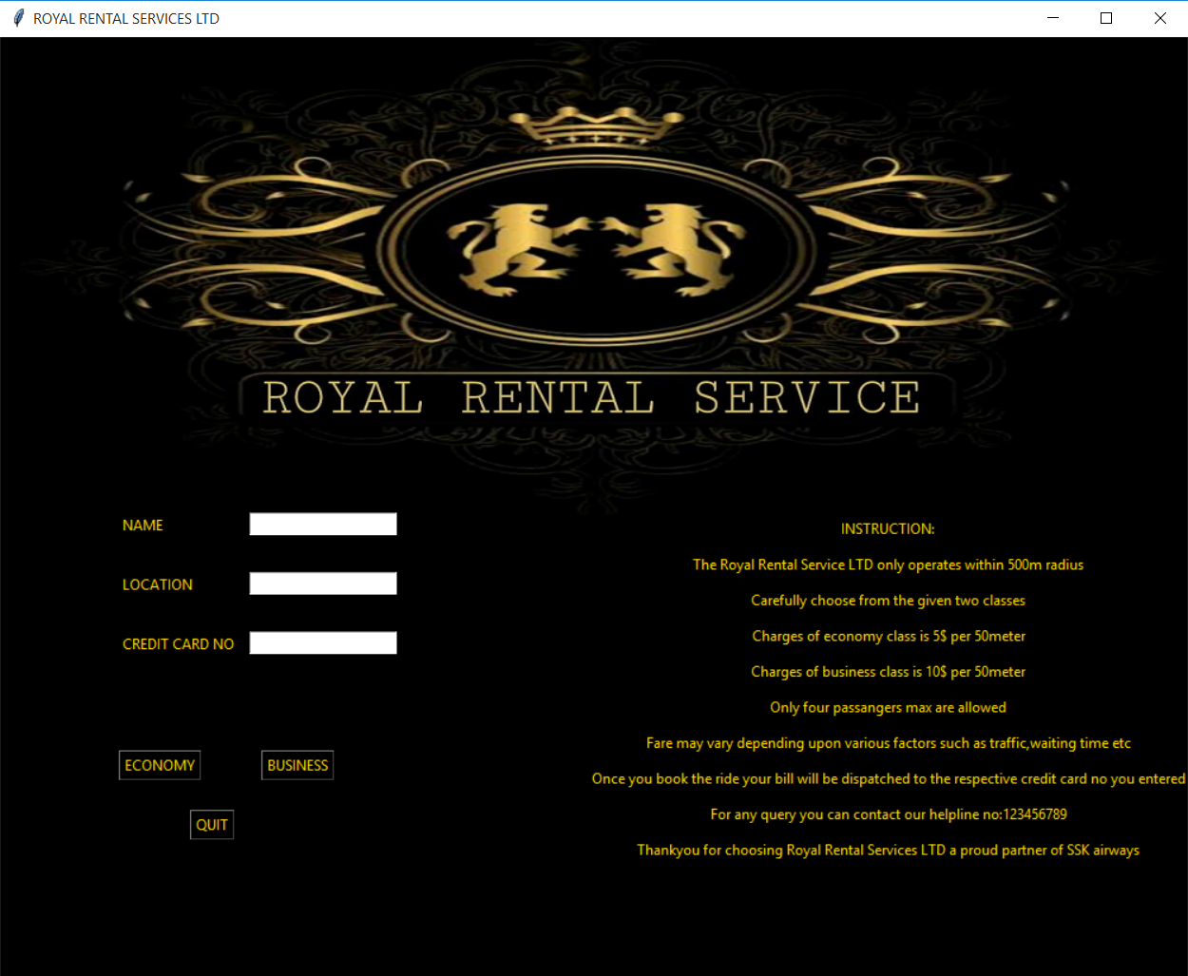

* + 1. *BOOKING:* This is the most important feature of all as it provides the passenger to book his flights online. Moreover it also generates the ticket so that the passenger can verify his journey.

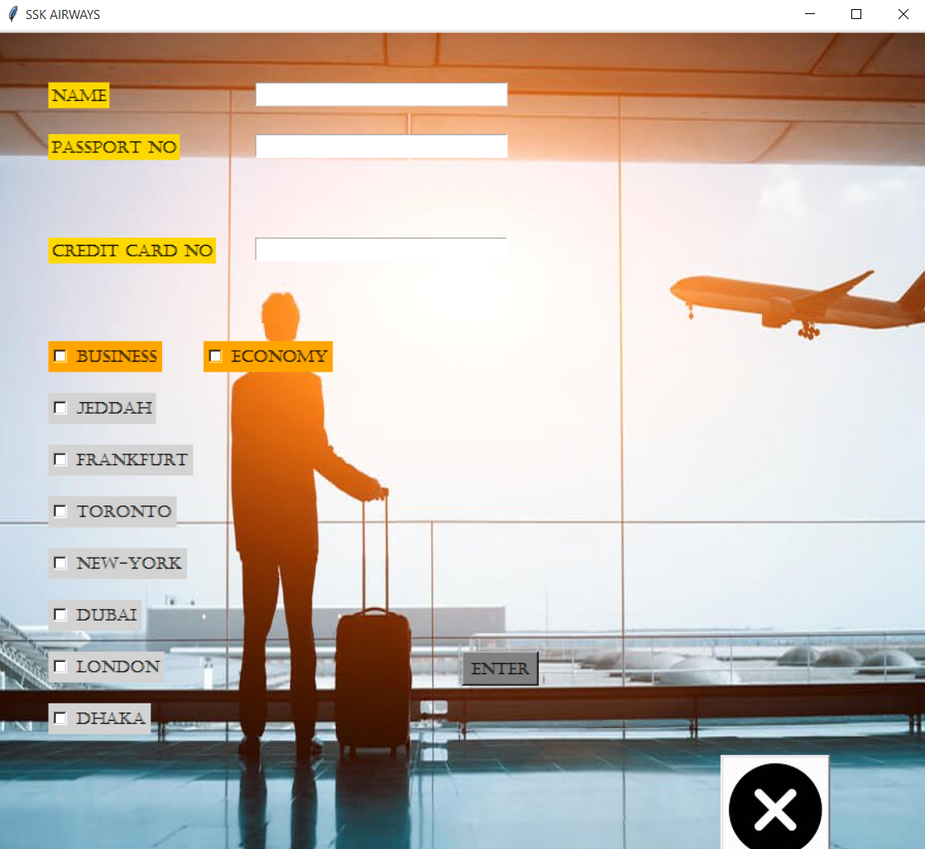

## FOR MANAGEMENT:

*MAIN PAGE:* Here the officials can access all the necessary contents which are required to run the organization smoothly.

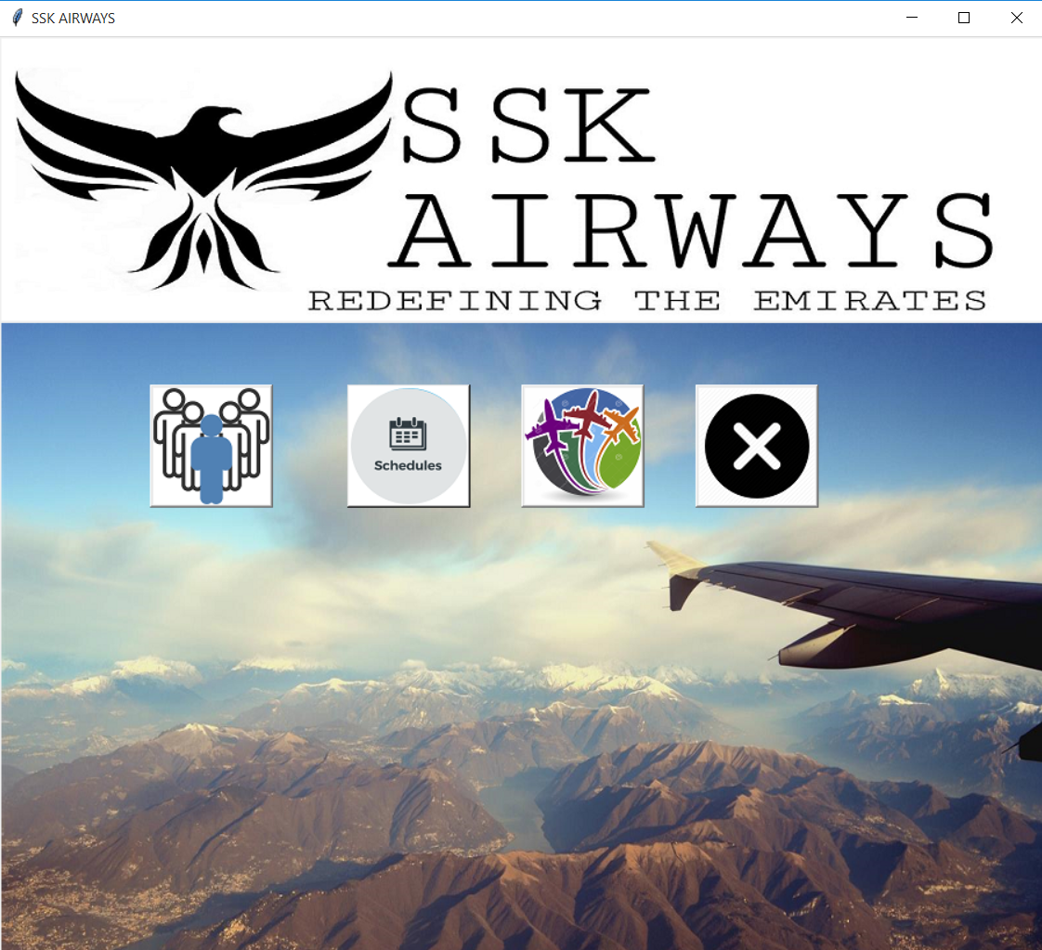

1. *EMPLOYEES:* This window contains all the database regarding the employees working for the organization.

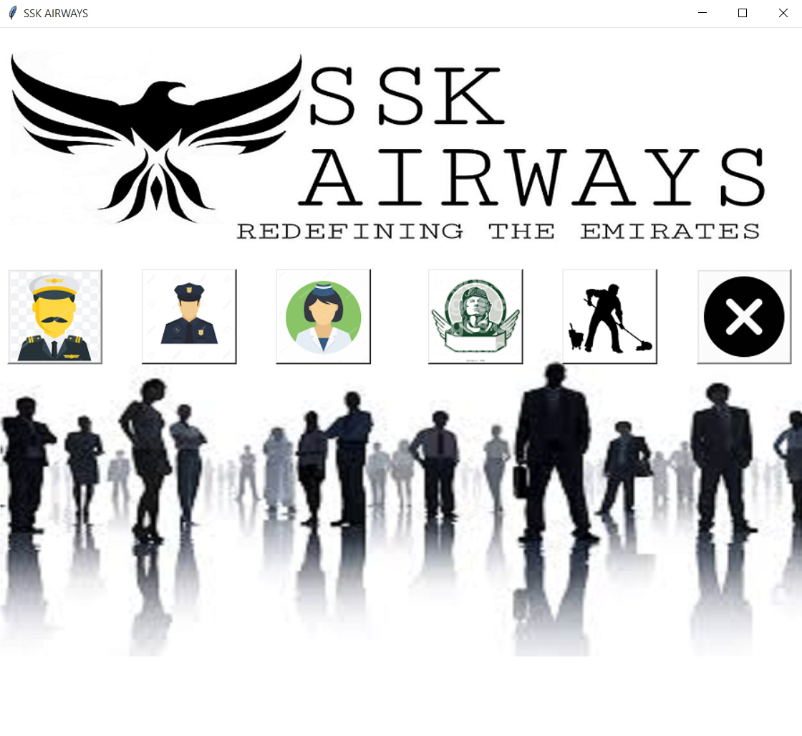

*ii) SCHEDULES:* This window contains the schedules of all the planes.

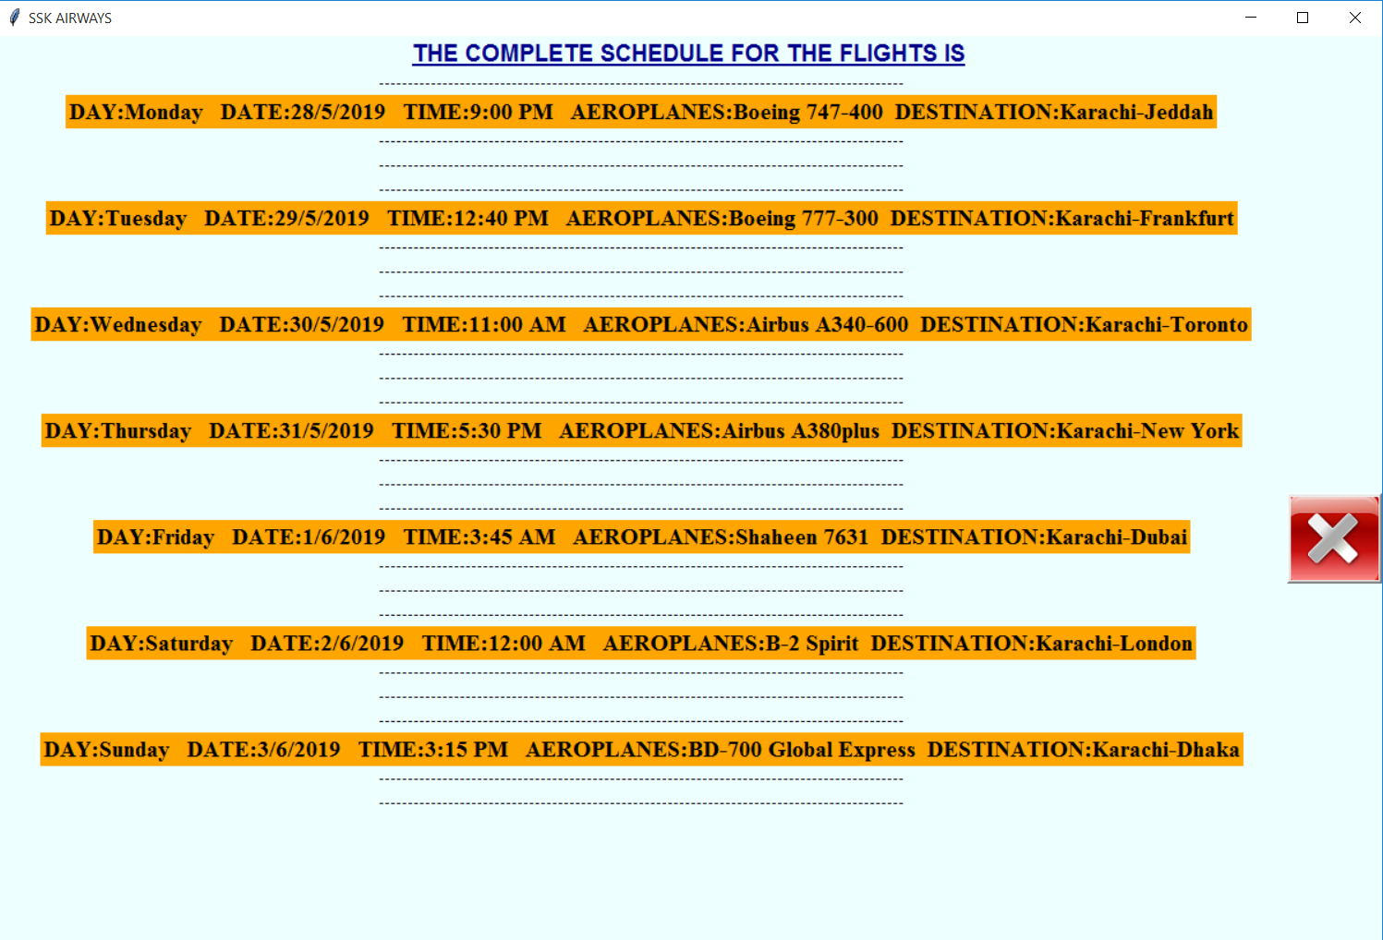

*iii) PLANES OF ORGANIZATION:* This window contains all names of the planes that are working for the organization.

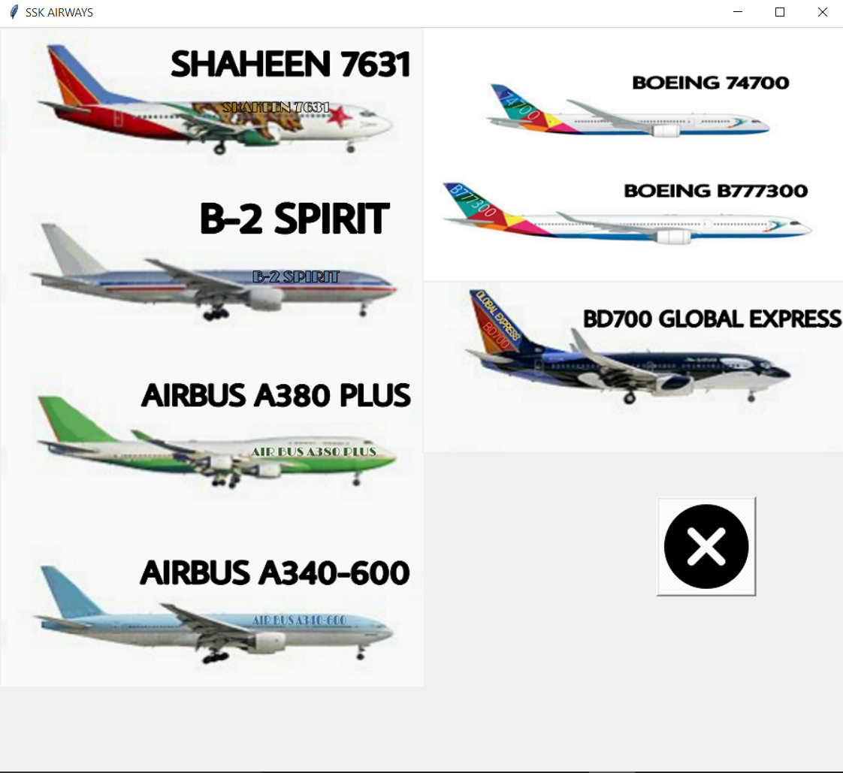

# OBJECT ORIENTED IMPLEMENTATION

## CLASSES:

Our code comprises of a total of fifteen (15) classes which also include five child classes of a particular class.

The names of these class are:

Incorrect username or password

Main page

Flights

Aeroplanes

Help corner

Creator1

Creator2

Creator3

SSKAirways

Employees

Pilot (Child class of employee)

Sky marshall (Child class of employee)

Air hostess (Child class of employee)

Janitor (Child class of employee)

Aviator (Child class of employee)

In these classes different concepts of object oriented programming are implemented which are further discussed.

## MULTIPLE INHERITANCE:

The concept of multiple inheritance is implemented in our code in the employee section which is created in a separate module in which a main class of employee maintains all the database of the employees working for the organization and all the child classes inherit this class and use only the specified data which they require as shown:

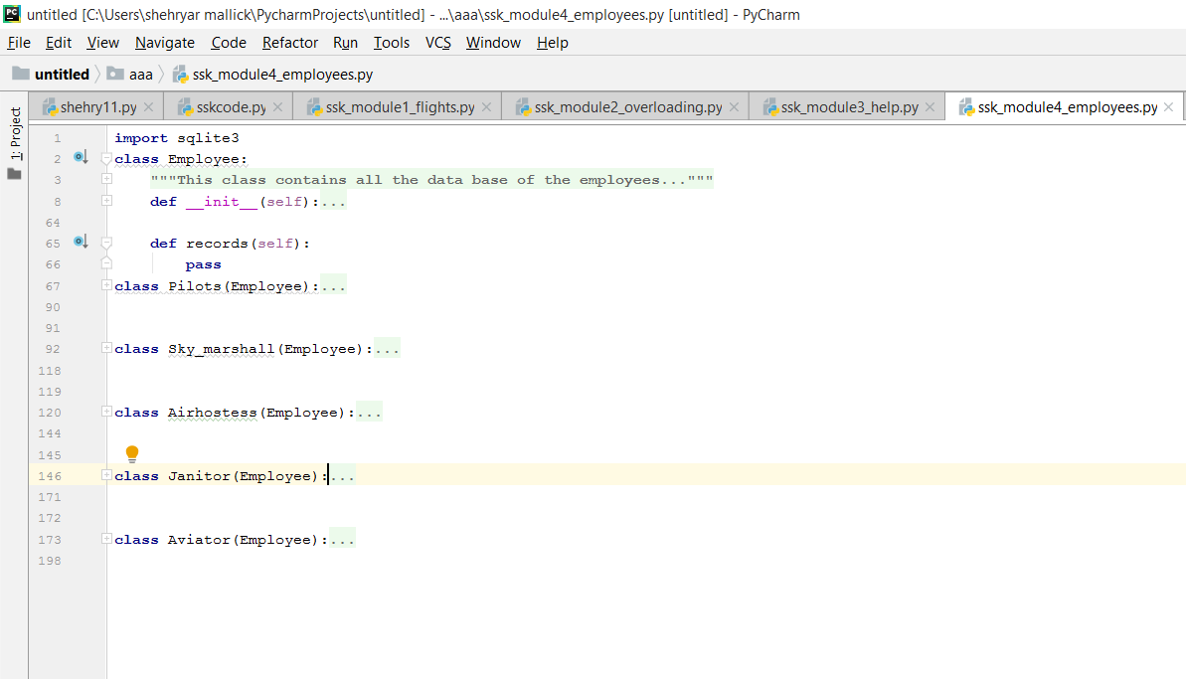

## AGGEREGATION:

Inorder to implement the concept of aggregation we have created a separate module in which the names of the creators are taken as an argument in separate classes and aggregation is performed in an another class named SSKAirways as shown:

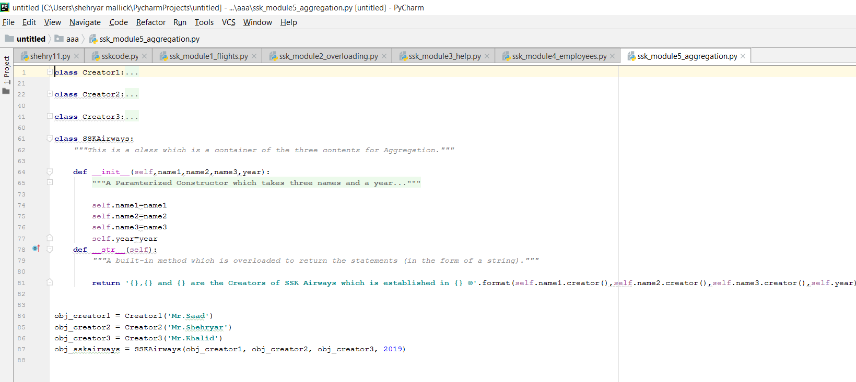

## OVERLOADING:

Inorder to implement the concept of overloading we have created a separate module in which we have applied overloading as shown:

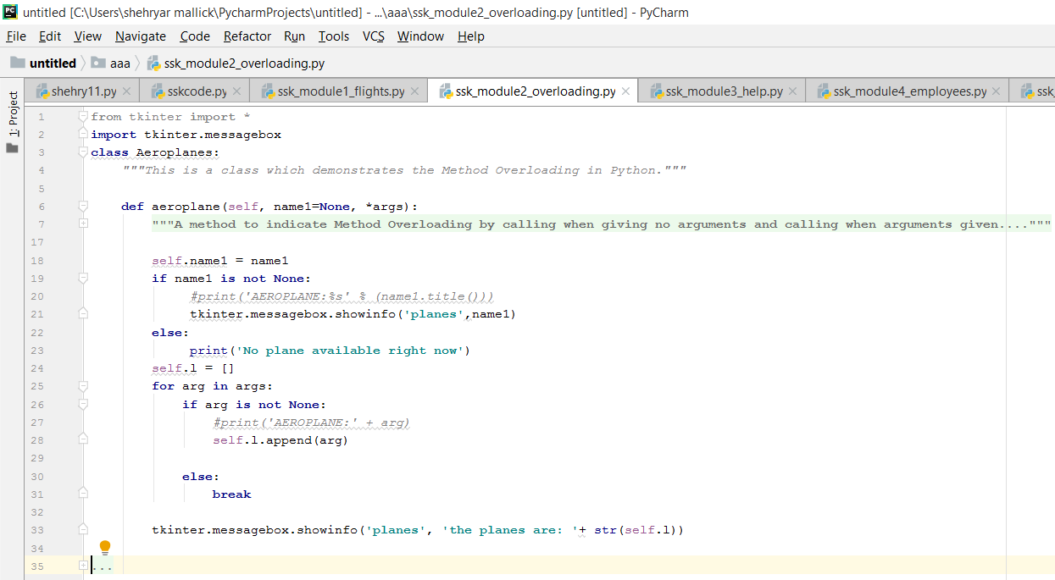

## OVERRIDING:

In the same manner to implement the concept of overriding we have the employee class in a separate module in which there is a particular method of records which is inherited by every child class and then that method is override according to necessity of the particular class. As shown:

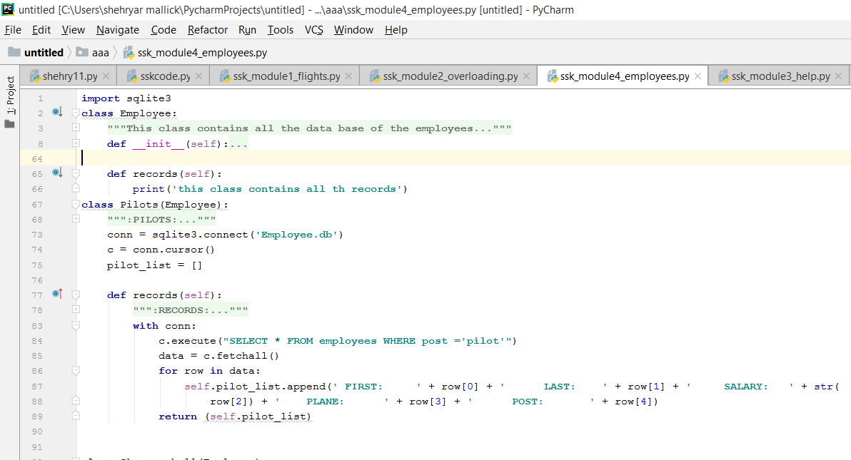

## EXCEPTION HANDLING:

The concept of exception handling has been implemented in two places in the main code so that in case of any exception we have created message boxes that will arise(pop up) as soon as the mistake is made as shown:

First implementation:

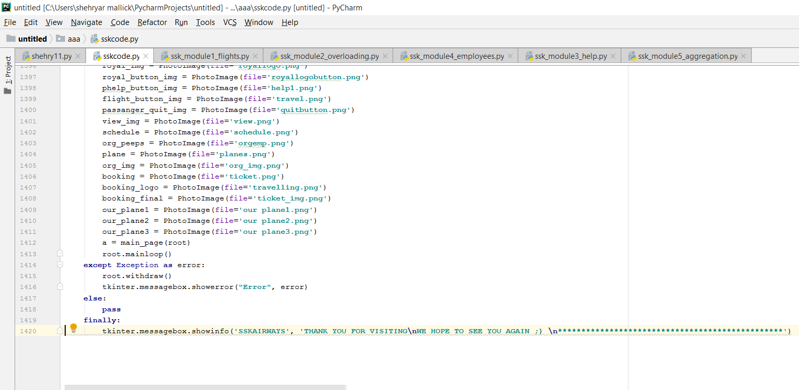

In case of exception:

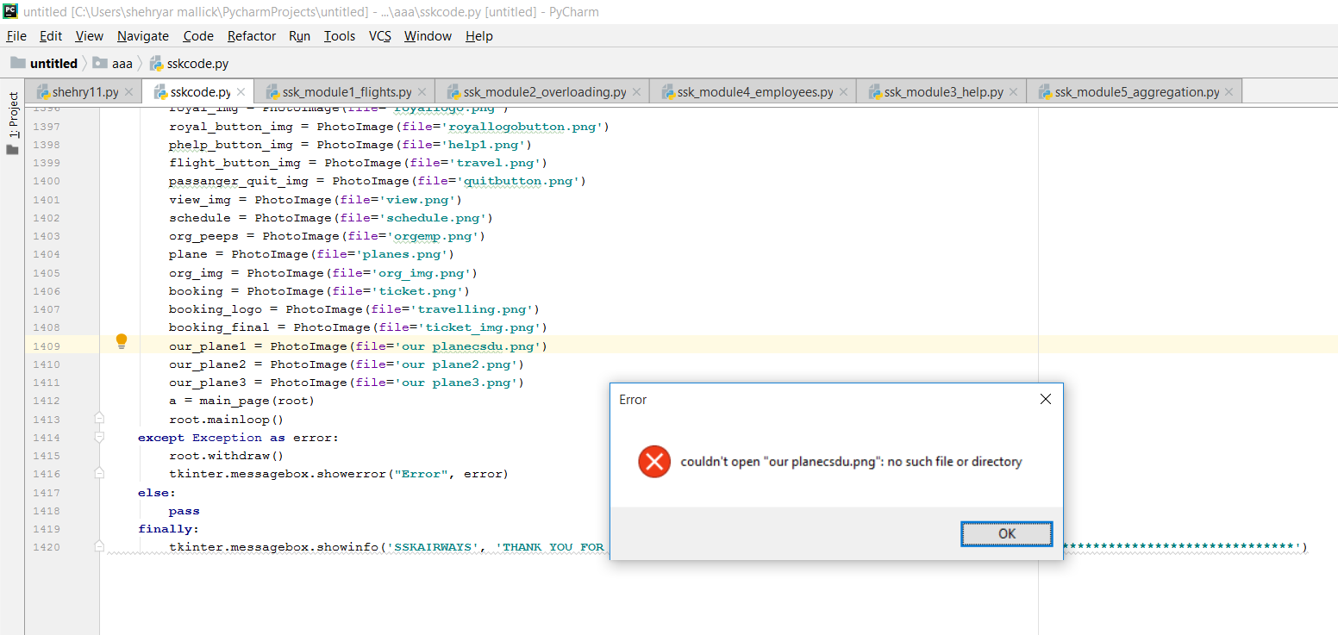

2nd implementation:

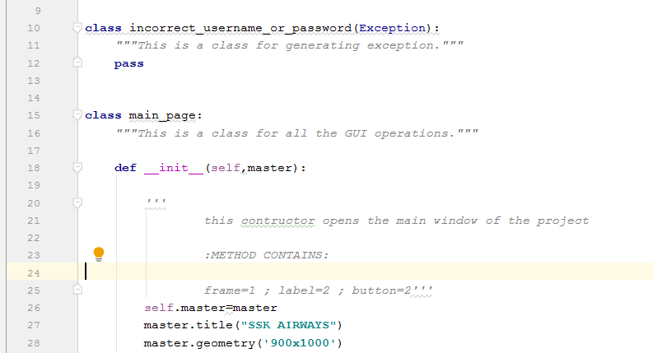

## MODULES:

We have for every object oriented concept created a separate module and then we have imported those modules into a main file of SSK code thus making a package as Shown:

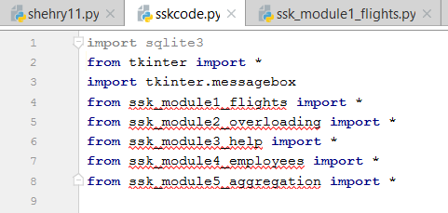

So, from the picture it is clear that we have created five modules.

# CONCLUSION

Summing up my report, in the end I would like to say that our airline system is a complete package which does not only accommodates the passengers with luxuries like booking a flight and other features as discussed above but also provides the staff of managements to keep a track of all the functionalities.

